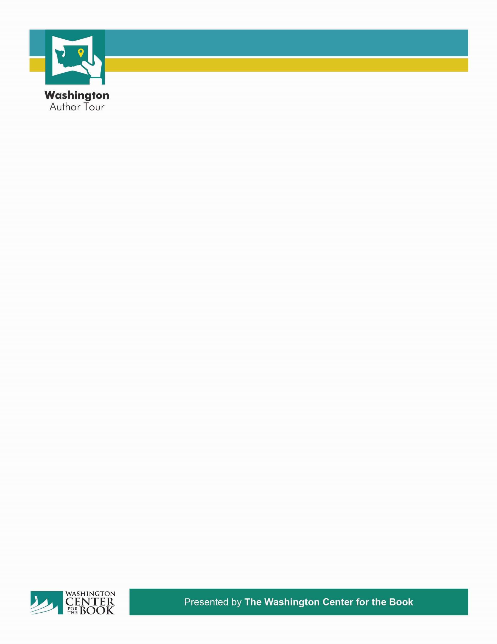

Time, Day and Date

Location of Library and Program

**Headline with author and book title**

Paragraph with description here- The Best We Could Do is a haunting memoir about the search for a better future and a longing for a simpler past. Thi Bui documents her family’s daring escape after the fall of South Vietnam in the 1970s and the difficulties they faced building new lives for themselves in America. **www.spl.org**

Insert Library logo here

Presented by Washington Center for the Book

And Your Library Here